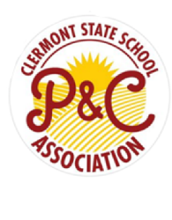**Clermont State School –  
P&C Book Packs**  
**Prep, 2025**

|  |  |
| --- | --- |
| Product | Required |
| Crayons Schoolpro Twistable 12pk | 2 |
| Eraser Large | 4 |
| Elmers PVA Glue 225ml | 1 |
| Glue Stick 36gm (bostik) | 8 |
| Marker Crayola Broad Line Classic 10pk | 1 |
| Pencil Lead Jumbo Tri HB Bx12 | 1 |
| Scissors Stat 140mm Soft Grip | 1 |
| Sharpener Metal Double W/Canister | 1 |
| Whiteboard Markers 4pk | 4 |
| Scrapbook Sovereign 64pg | 7 |
| Writer Premium Story Book 330x 240mm Plain + 24mm Ruled 64pg | 1 |
| Writer Premium Story Bk 330x 240mm Plain+QLD Yr1 Ruled 64p | 1 |
| Exercise Book A4 Year 1 48pg | 2 |
| Exercise Book Olympic A4 18mm 48pg | 2 |
| Sketch Book A4 40pg | 1 |
| Multi-Purpose Pouch A3 (homework case) | 1 |
| Clipfolder A4 Black | 1 |
| Tissues 2ply 200's (Delivered to school) | 2 |
| Copy Paper Victory A4 High White 80GSM | 1 |
| Multi-Purpose Pouch A5 (pencil case) | 1 |
| Bluetooth 5.1 Foldable Over-Ear Headphones | 1 |
| Library Bag (purchased from Tuckshop) - $9.00 | 1 |
| **TOTAL** | **$150** |

|  |
| --- |
| Notes: |
| * All school equipment and items must be clearly labelled with child’s name. * Consumable items such as pencils, glue and exercise books may need to be topped up throughout the year – your child’s class teacher will email about this. |

**P & C Book packs can be purchased through the flexischools App -**  
*(They can be located under the “Shop” button – select student – click uniforms – select date (date is not accurate – you will be contacted when pack is ready to collect) – Choose which book pack is required)*