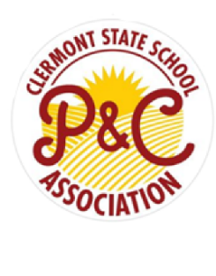**Clermont State School**   
**Year 5, 2025**

|  |  |
| --- | --- |
| Product | Required |
| Eraser Large (Staedtler) | 4 |
| Glue Stick 36gm (bostik) | 8 |
| Highlighters 6pk | 1 |
| Marker Crayola Supertip Washable 10pk | 1 |
| Pen – Blue | 1 |
| Pen – Black | 1 |
| Pen - Red | 2 |
| Pencil Coloured Faber-Castell Hexagonal Bx12 | 1 |
| Pencil Lead Staedtler HB Bx12 | 1 |
| Ruler Wooden 30cm | 2 |
| Scissors Stat 170mm Soft Grip | 1 |
| Sharpener Metal Double W/Canister | 1 |
| Whiteboard Markers 4pk | 1 |
| Protractor | 1 |
| Exercise Book A4 128pg | 10 |
| Graph Book A4 48pg 10mm | 4 |
| Scrapbook Sovereign 64pg | 2 |
| Sketch Book A4 40pg | 1 |
| Student Diary 2025 | 1 |
| Multi-Purpose Pouch A3 (homework case) | 1 |
| Display Book A4 | 2 |
| Document Wallet F/C Clear | 2 |
| Manilla Folder Single | 1 |
| Clipfolder A4 Black | 1 |
| USB Shintaro 2.0 16GB | 1 |
| Bluetooth 5.1 Foldable Over-Ear Headphones | 1 |
| Tissues 2ply 200's (Delivered to school) | 2 |
| Copy Paper Victory A4 High White 80GSM | 1 |
| **TOTAL** | **$150** |

|  |
| --- |
| Notes: |
| * All school equipment and items must be clearly labelled with child’s name. * Consumable items such as pencils, glue and exercise books may need to be topped up throughout the year – your child’s class teacher will email about this. * **Pencil case & library bag are also required for all students** |

**P & C Book packs can be purchased through the flexischools App -**  
*(They can be located under the “Shop” button – select student – click uniforms – select date (date is not accurate – you will be contacted when pack is ready to collect) – Choose which book pack is required)*